SOFTWARE DESIGN DESCRIPTION

RecipEasy

By: David Palmieri, Brandon Adams, Yunkai Deng, Chris Costa and Nathaniel Poli

3/29/2016

Table of Contents

1. INTRODUCTION 2

1.1. Product Overview 3

2. SYSTEM DESIGN DESCRIPTION OVERVIEW 4

2.1. Introduction 4

2.2. System Architecture 4

2.2.1. Software UML 4

2.2.2. Database UML 5

2.3. System Interfaces 5

2.3.1. User Interfaces 5

2.3.2. Software Interfaces 6

3. FILE AND DATA BASE STRUCTURES 7

4. MAJOR INTERNAL DATA STRUCTURES 8

# INTRODUCTION

## Product Overview

At the center of RecipEasy is a JDBC derby database. This will be queried by the user interface to return data to the user. It will also contain user information and passwords, as well as user favorites and preferences. The scraper class will only be used once, to build the initial recipe database. The scraper class gathers data via HTML forms from bettycrocker.com and the parser class gathers all the pertinent information from those forms. Then that information is passed to the recipe class to build recipe objects. These recipe objects are then put into the database.

# SYSTEM DESIGN DESCRIPTION OVERVIEW

## Introduction

The description overview is section to introduce and give a brief overview of the design. The system architecture is a way to give the overall view of a system and to place it into context with external systems. This allows for the reader and user of the document to orient themselves to the design and see a summary before proceeding into the details of the design.

## System Architecture

### Software UML

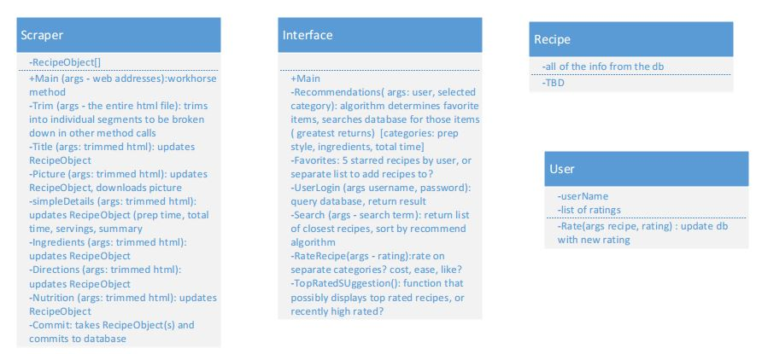

### Database UML

## System Interfaces

### User Interfaces

The user interfaces for this software will allow the user to easily search for recipes, save recipes, and rate recipes. The user should be presented with all main functions on the main user interface page to allow for the user to select the function to use without the need to navigate inward to find it. The interface will be used by various operating systems.

Login GUI:

+ User name text field: input username

+ Password field: input password associated with the username

+ Sign In button: click to launch main page

Search GUI:

+ Keywords text field: input keywords related to interested recipes

+ Recipe info field: return a list of search results

+ Search button: click to perform search recipes action

Recipe Info GUI:

+ Recipe name text field: is used to display recipe name

+ Ingredients field: is used to display detailed ingredients

+ Nutrition field: is used to display nutrition information

+ Direction field: is used to display steps on how to cook

+ Back button: click to perform go back to recipe list action

### Software Interfaces

The software will need to interface with a database management system to pull data from it and push data updates to it.

# FILE AND DATA BASE STRUCTURES

The following is the UML for our Database showing all of the relationships with in it.



# MAJOR INTERNAL DATA STRUCTURES

The recipe class is our major data structure.

